LAB TASK 6

Q1

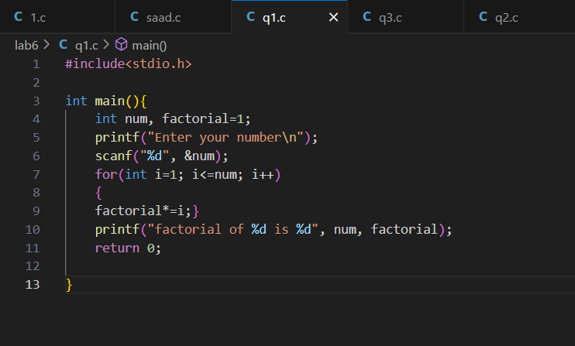

Q2

Q3

Q4

Q5

Q6

